How to deploy files on clients (67.62.160.107)
Main Path :- P:\webapps\asiship\
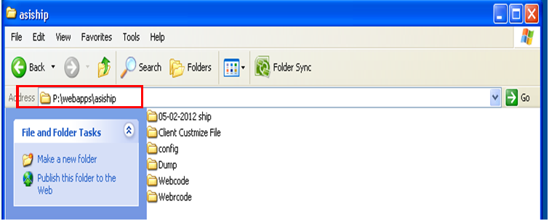

.ASPX and Progress Files Path
For .ASPX files Path : - P:\webapps\asiship\webcode
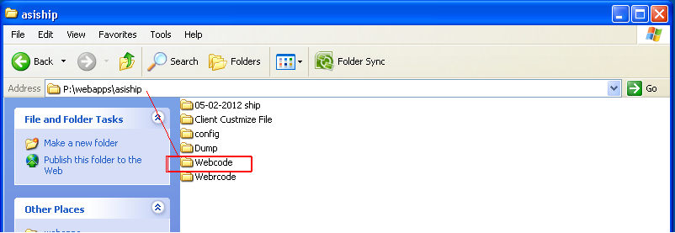

Note :- Never replace the web.config file of webcode folder.
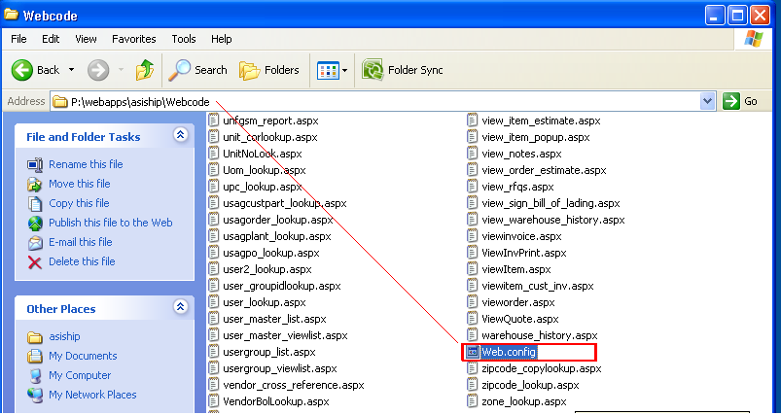

For Progress files Path : - P:\webapps\asiship\webrcode
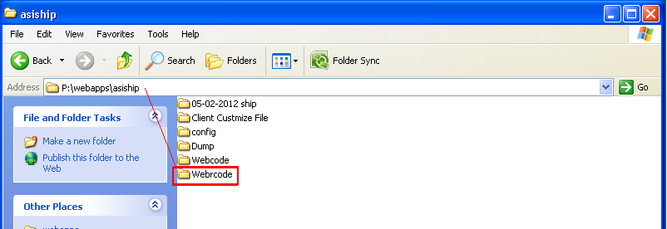

Customized Files Path for Particular Clients
Never replace following customize files from P:\webapps\asiship\
- Webrcode\Reports\invhighprt.r
- Webrcode\ Reports\invhighreport.r
- Webrcode\ Reports\invhighreport2.r
- Webrcode\ Reports\prodhighprt.r
- Webrcode\ Reports\prodhighreport.r
- Webrcode\ Reports\prodhighreport2.r
- Webrcode\ Reports\bookinghighreport.r
- Webrcode\ Reports\bookinghighreport2.r
- Webrcode\ Reports\salesrephighreport.r
- Webrcode\ Reports\salesrephighreport2.r
- Webrcode\ Reports\processfile.bat
- Webrcode\ Reports\profile.bat
- Webrcode\ Reports\viewcalc.bat

Remarks :- If there is need to change/replace in the above files for clients then we can only change/replace on below path, Don’t do on above paths. When we go on the below path we found that there is different folder option for different clients :-
For Customized files Path : - P:\webapps\asiship\Client Custmize File
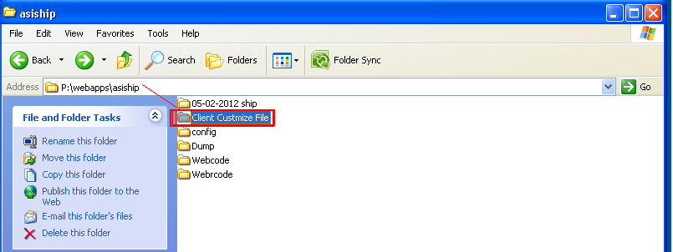

For Accord Server files Path
(197.168.0.14)
For .ASPX files - D:\ webapps\webcode\
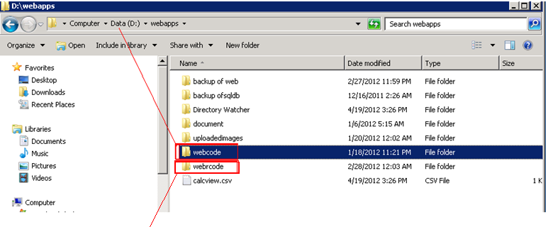
For Progress files - D:\ webapps\webrcode\
How to start Xspool and Dirctory Watcher (When Server Restarted)
- Run D:\webapps\directory Watcher\fil watcher simple.exe (As shown in below attachement)
- Double click on below shown xspool icon ( Xspool are install on advantzware users).
